GOLDEN WARRIORS

JUANJO LONDOÑO: COORDINATIOR
LIAN MIGUEL: SECRETARY
NIKA CHEN: SPEAKER N’ GEEK
DAVID FRANCO: P.E INVENTOR
ELLYN VIEIRA: HELPER

WHAT AND HOW DID WE DO THE ACTIVITIES?
We have performed a report about the development of a circuit composed by ten exercises. Within each exercise we were training different muscles.
MATERIAL:
BOSU BALL
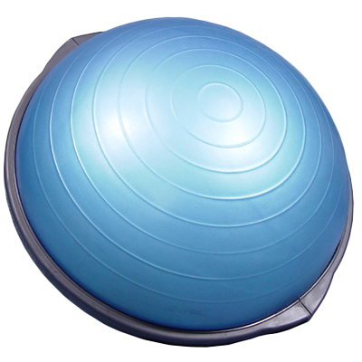
MAT
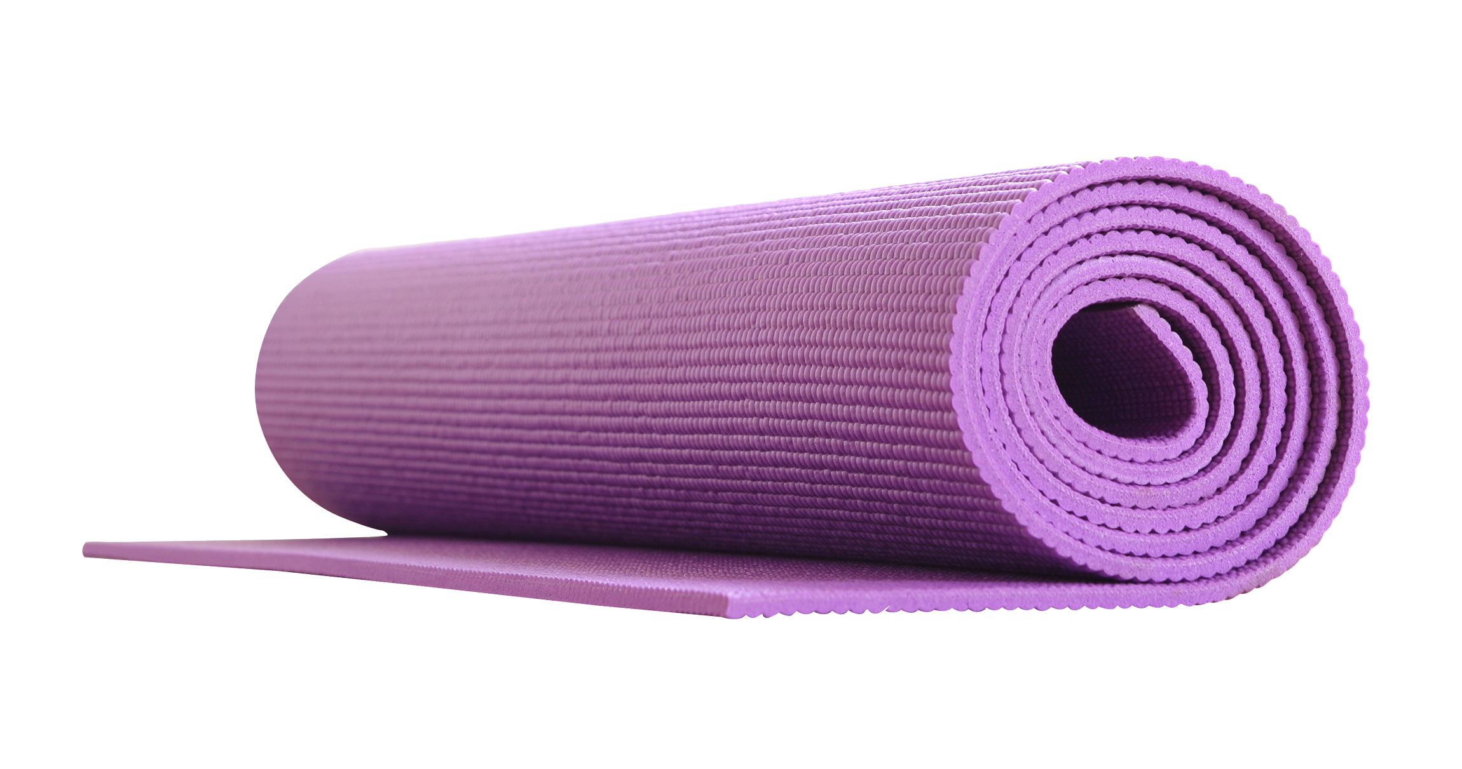
BENCH
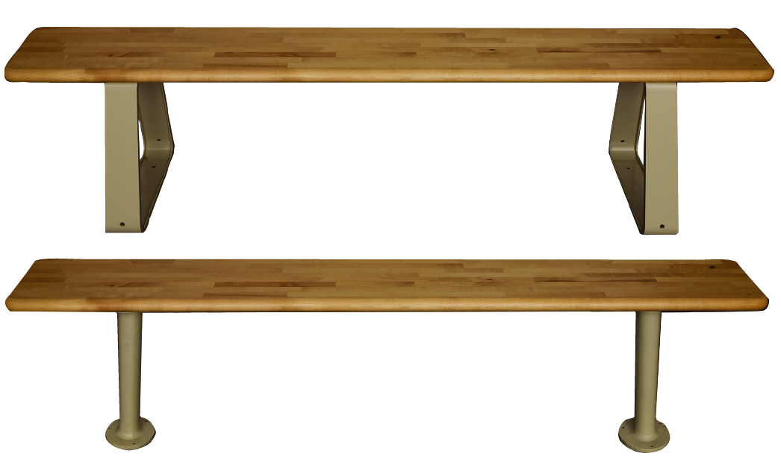

STRETCHING:
Quadriceps Stretch: Clasp your foot behind your body with opposite hand. Pull your foot upwards, and push the knee backward. Contract your abdominals to stabilize the pelvis. Press the front hip bone forward and slightly extend the hip. Hold the stretch. Repeat for each leg 5 times.
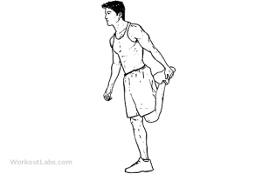

Posterior Shoulder Stretch: Stand straight while maintaining the natural arch in your lower back. With your shoulders down and relaxed, reach one arm across your chest, parallel to the floor. With the other arm, place your hand on the elbow. Gently pull your elbow in toward your chest. Hold the stretch. Relax and repeat on opposite side. Repeat 5 times.

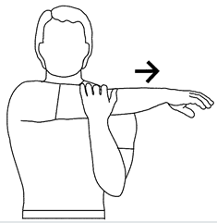

ACTIVITIES:
- Bridge: First you have to lie down on the floor. After this you have to raise your gluteus.
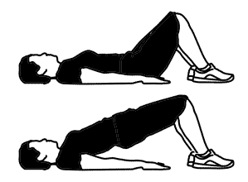

- Leg raises: First you have to lie down on the floor. Then you have to raise your legs and hang them. You can do this series 15 times.
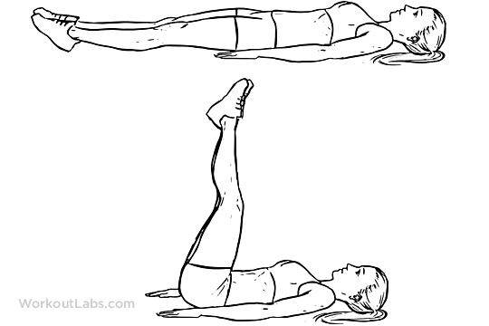

- Push-up: First get into position by placing your hands flat on the floor, directly below your shoulders.
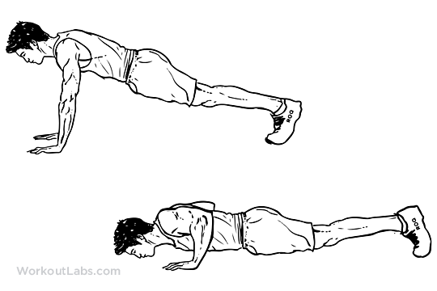
- Jump squats: Take the proper stance, lower yourself into a squat. Then, initiate the jump, as high as you can. Don't forget to control your descent. Repeat this for 15 times.
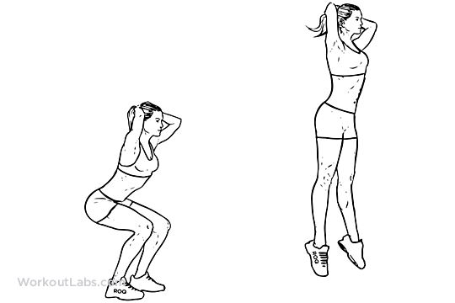
- Plank: Stay in the same stance as a normal push-up for 30 seconds.
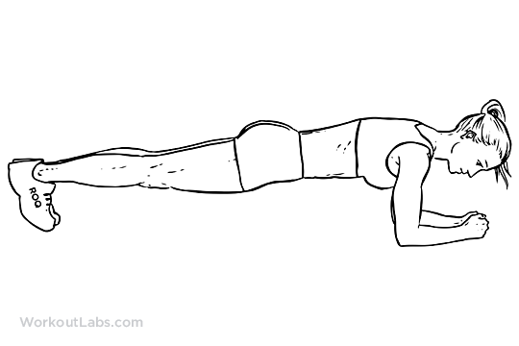
- Banch step up: To start, place your entire right foot onto the bench or chair. Press through your right heel as you step onto the bench, bringing your left foot to meet your left so you are standing on the bench. Return to the starting position by stepping down with the right foot, then the left so both feet are on the floor. Repeat this for 15 times.
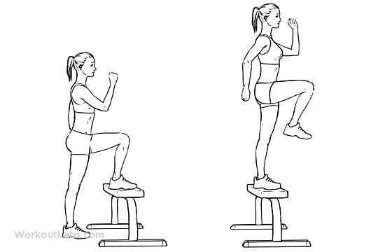

- Abs: Lie on your back, and bring your knees up to a 90-degree angle. Place your hand behind your head and bring your shoulders off the ground. Exhale and contract your abdominals to your knees. Then go to the starter position. Repeat this for 15 times.
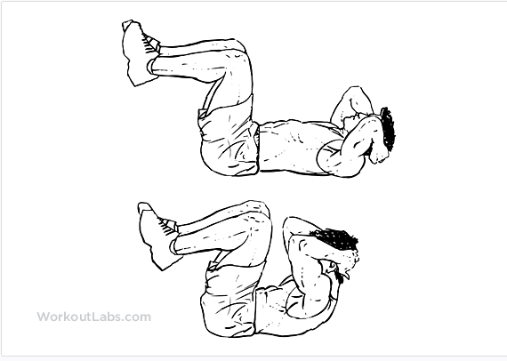
- Lunge:
Keep your upper body straight, with your shoulders back and relaxed and chin up. Always engage your core. Step forward with one leg, lowering your hips until both knees are bent at about a 90-degree angle. Make sure your front knee is directly above your ankle, not pushed out too far, and make sure your other knee doesn't touch the floor.
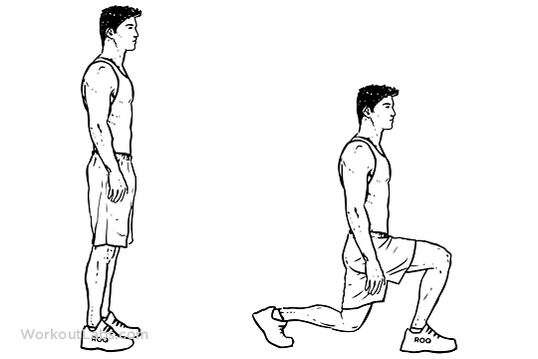
- Bosu Ball Plank Leg Lifts: Place a BOSU Ball on the ground with the blue rubber side facing up. Carefully, place your elbows on each side of the rubber side. Take a push-up position. Make sure your feet are together, core is tight and hips are level. Slowly, raise your left foot up in the air. Do this series for 15 times.

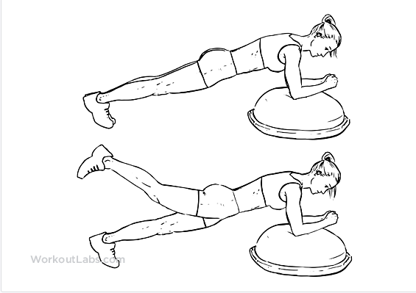

- Jumping jacks: Stand with your feet together and your hands at your sides. Simultaneously raise your arms above your head and jump up just enough to spread your feet out wide. Without pausing, quickly reverse the movement and repeat.
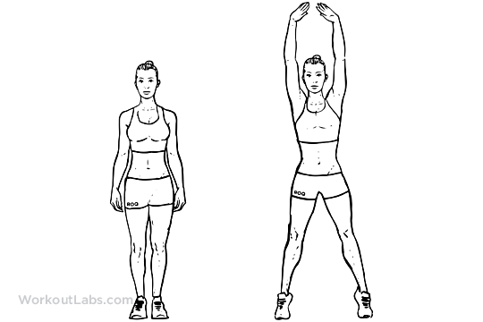

- Agility ladder drills: Lay out the agility ladder on a non-slip surface. Perform a routine of choice.

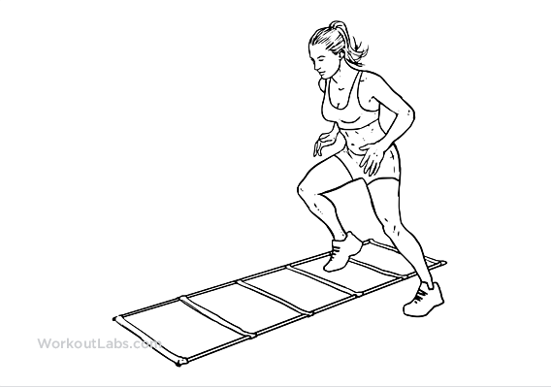

- Cycling crunches: Start as if you were cycling, pedaling. Bring your right knee towards your head as you rotate your upper body. Try to touch your left elbow to your right knee. Then straighten your right leg back as you bring your left knee in. Simultaneously rotate your upper body to the opposite side. Try to touch your right elbow to your left knee. Do this series 1 minute.
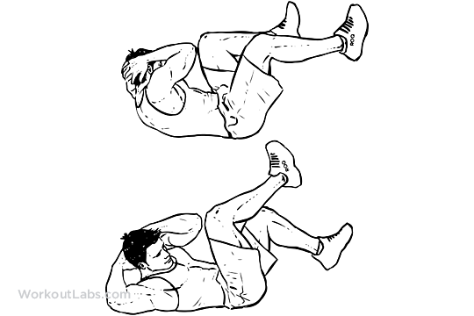

STRETCHING:
Side Trunk Stretch: Begin with feet slightly apart, and arm pointing overhead, held by the opposite hand. Keeping your hips stable, bend your torso so that the stretch is felt along your side. Hold the stretch. Repeat this for 5 times.
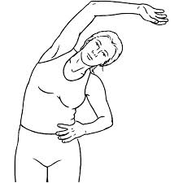

Hamstring Stretch: Sit on the floor with the leg to be stretched extended, and the other leg bent with the foot towards your body. Reach out with your hands, lean your upper body forward, and bring your chest towards your thigh. Make sure you don't round the upper back, and your lower back should be slightly curved. Get to the point of a mild stretch and hold. Do this for 15 seconds.
